On the letter Head of the Firm

ACCEPTANCE OF RATE OF MINIMUM MARKING FEE

This is with reference to our A- ______________(Application Number)

We hereby agree to pay marking fee to Bureau of Indian Standards after grant of license to use the Standard Mark on __________________(Product Title) as per IS _______________according to ________________(Product Manual Number) at the following rates and in the manner stipulated as under:

- Rate of marking fee:
MMF: ___________(INR) for ___________(Scale)
Unit: ____
Unit Rate: ________(INR)

- The marking fee is payable as follows:
  - Minimum marking fee for one operative year payable in advance which will be carried over to next renewal(s).
  - Actual marking fee for the first nine months of the operative period calculated on the unit rate on the production marked or the minimum fee whichever is higher shall be payable at Delhi/New Delhi at the time of the first renewal of the license. For subsequent renewals, the actual marking fee for 12 months period consisting of last three months of previous operative year and the first nine months of the current operative year or the minimum fee whichever is higher, shall be payable.

For Company Name
Name:
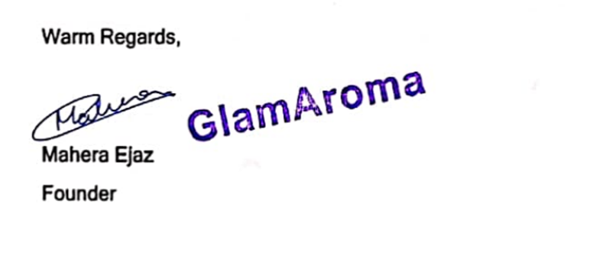
Designation:
Date

